|  |  |  |  |  |  |
| --- | --- | --- | --- | --- | --- |
| Date | 30-Nov-22 | | | Tester Name | Andrew McLaughlin |
| Environment | Penfax - Test | | | Login used |  |
| Operating System | Select OS | Version: | Update: | | |
| Software Used | Select Software | Version: | Update: | | |
| Select Software | Version: | Update: | | |
| Release version | 22.4.1 | | | | |
| Title | Cancel of Suspension Retro calculated correctly | | | | |
| Test Type | Regression | | | | |
| Test Scenario | Cancel of Suspension Retro calculated correctly | | | | |
|  |  | | | | |
| Expected Results |  | | | | |
| Pass/Fail | Pass | | | JIRA# | N/A |

Describe your steps with screenshots:

Member has been suspended effective Jan 1 2018. 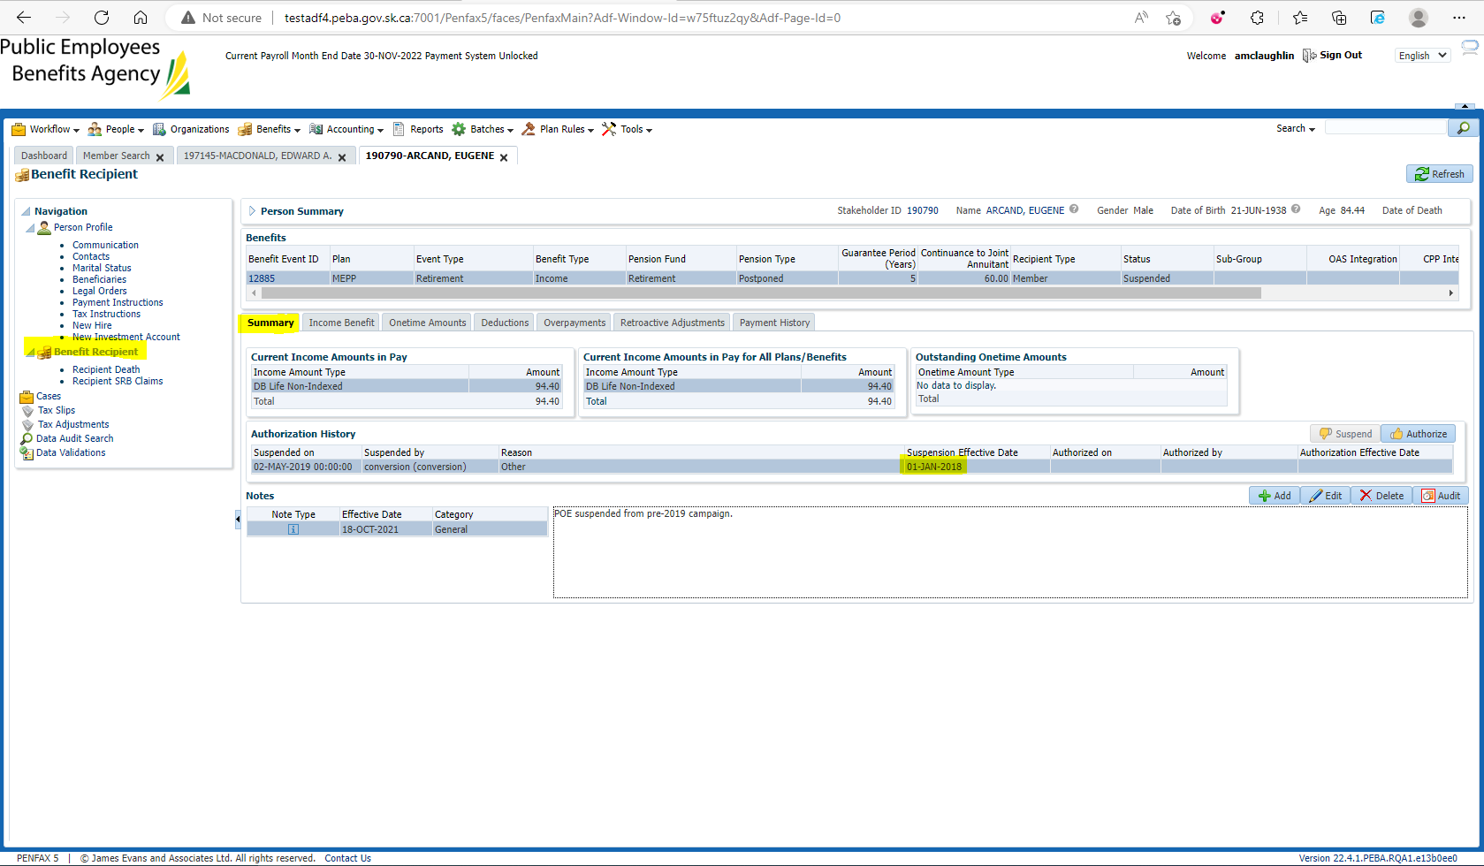

Reauthorize the pension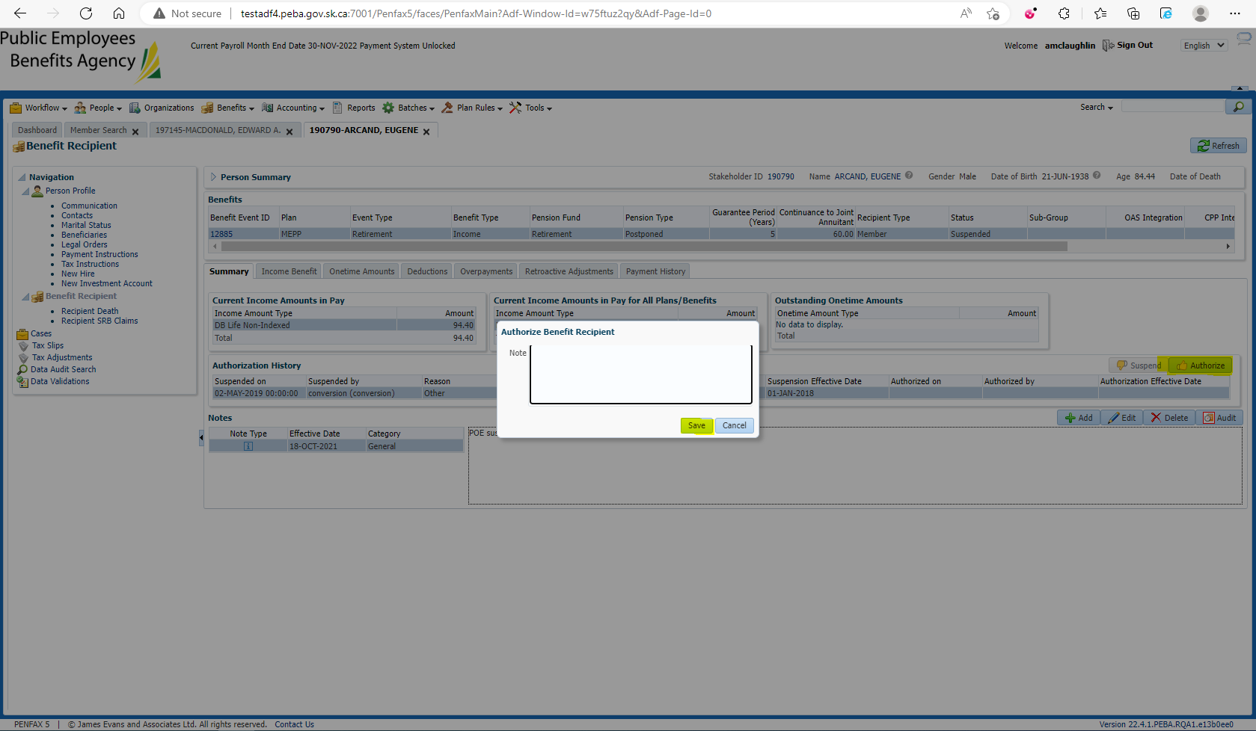

Under the Onetime Amounts tab, a retropayment is generated for the 58 months missed (48 without index, 10 with index) 48 months * 92.94 + 10 * 94.40, = $5,405.12